**SQL Assessment 2:**

1.Write a SQL statement to create a simple table countries including columns country_id,country_name and region_id.

**Ans**:-create table countries (country_id int ,country_name varchar(50) ,region_id int );

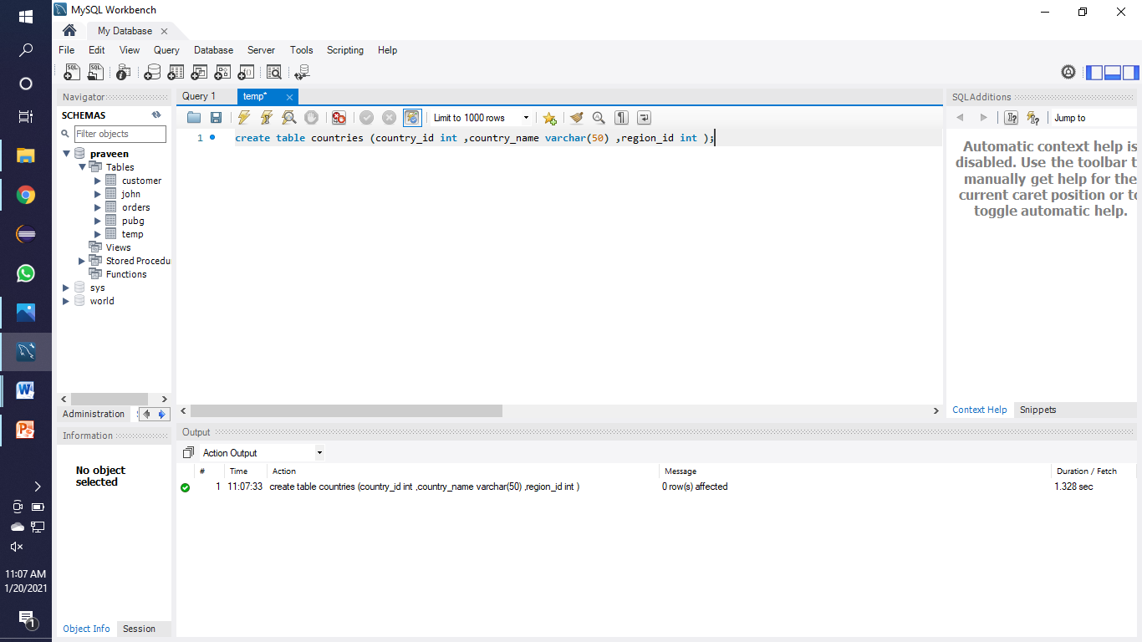

2. Write a SQL statement to create a simple table countries including columns country_id, country_name and region_id